**Database Management System**

**(Lab Task No 03)**



Session (2022-2026)

Program/Class

**BS-Computer Science / 5rd Section-A**

Submitted By:

Student Name: Shaheer Ali Roll Number: 301-221044

Supervised By:

Ms. Muneeba Darwaish

Lecturer

CS& IT Department

**Hazara University, Mansehra**

**1. Create a database:**

Create a database and name it school.

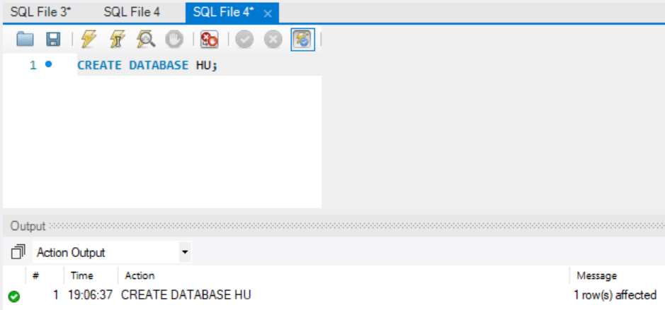

**2. Create a table:**

In the school database, create a table named result with 7 attributes related to student results.

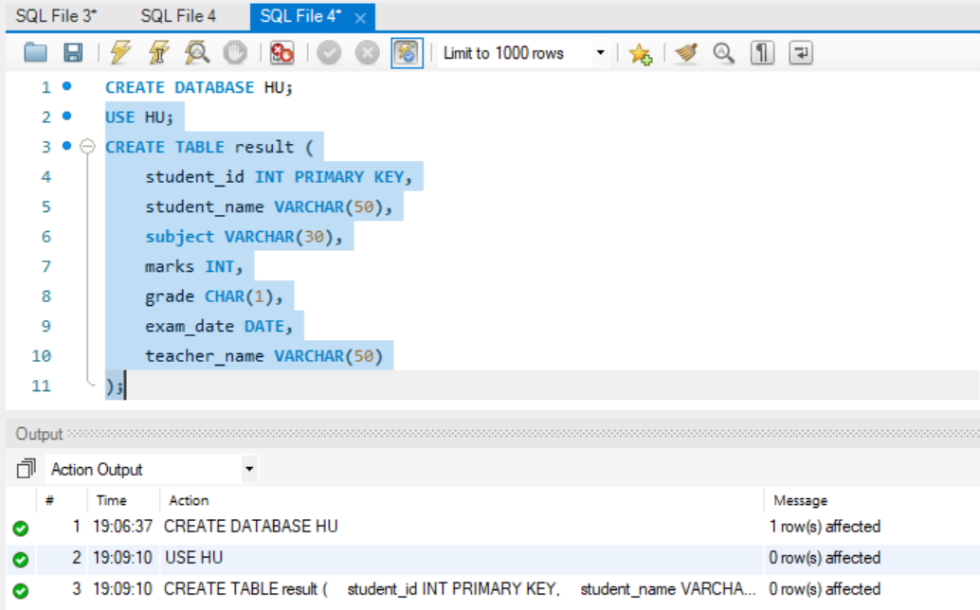

**3. Insert data into the table:**

Insert 10 rows of data into the result table.

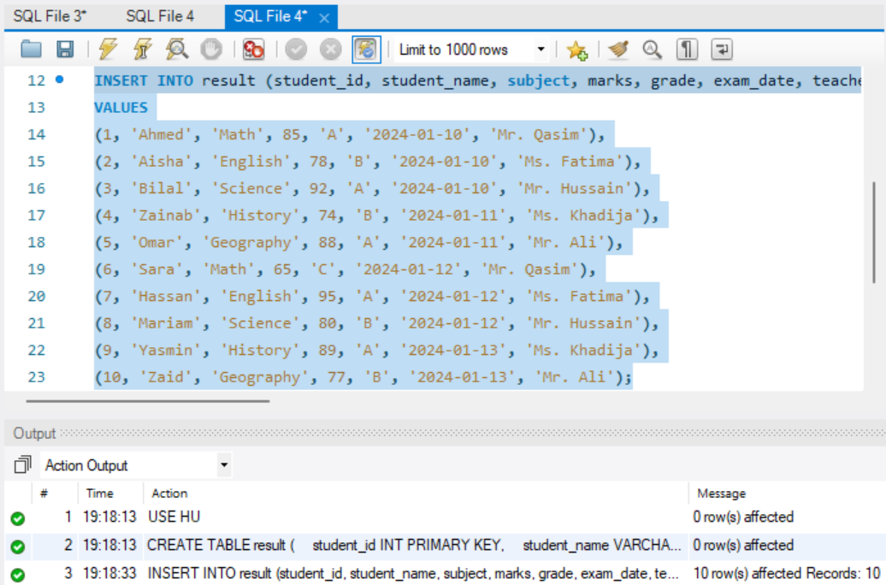

**4. Create a new table:**

Create a new table resultcopy by copying 3 attributes from the result table.

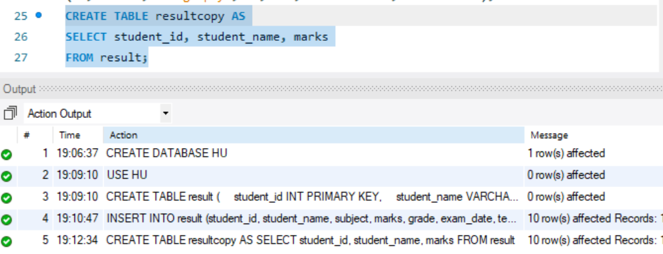

**5. Delete the resultcopy table:**

After copying the 3 attributes, drop (delete) the resultcopy table.

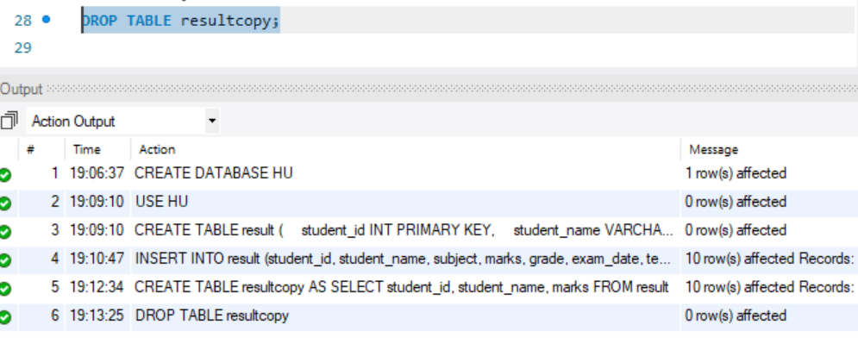

**6. Display the original table:**

Finally, display all the records from the result table.

